**UML Diagrams:**

1. **Use Case Diagram:**

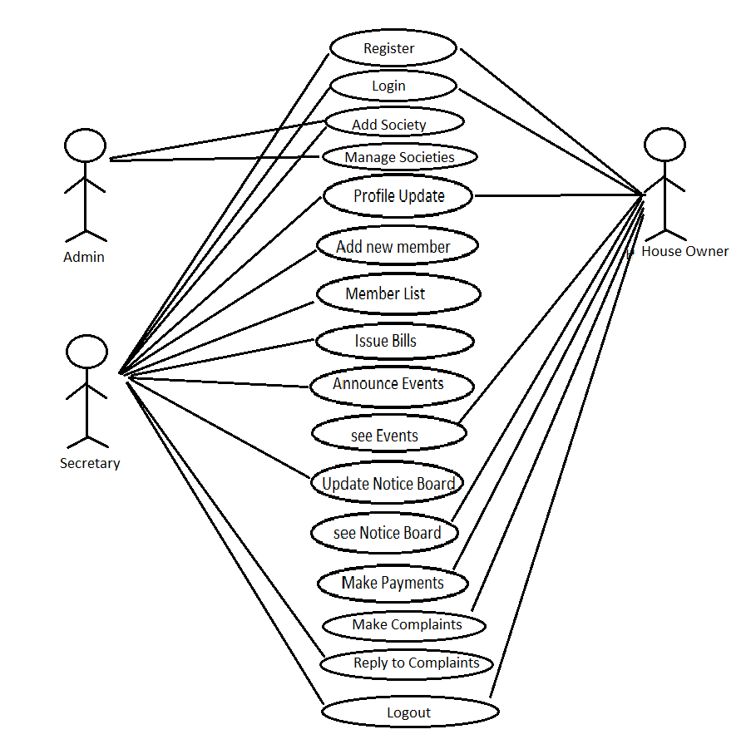

1. **E-R Diagram:**

**Entities:**

Admin………

Id

FirstName

LastName

emailId

ContactNo

Secretary……….

Id

FirstName

LastName

Address

emailId

ContactNo

HouseOwner……….

Id

FirstName

LastName

Address

emailId

ContactNo

FamilyMembersDetails

Society……….

SocietyName

SocietyAddress

SocietyLocation

SocietyDetails

MaintenanceBills…………

ElectricityBill

WaterBill

CleaningMaintenance

RegularFunds

Payment….……..

Id

PaymentDate

PaymentStatus

MemberList………..

Id

FirstName

LastName

Address

emailId

ContactNo

FamilyMemberNo

PaymentStatus

AnnounceEvents………..

EventSubject

EventDetails

EventDate

EventOccation

EventFundDetails

EventVenueDetails

NoticeBoard………….

NoticeDate

NoticeSubject

NoticeDetails

ComplaintBox…….

ComplaintId

UserId

Subject

Complaint

Reply

Status

Claim ………

UserId

Password